# HW 10: 251/502

# Part 1

For each of the datasets, please list the type of attributes (eg quantitative, qualitative, categorical, continuous, etc. ). More than one can be used to describe a variable (eg quantitative continuous or qualitative categorical, etc…). Then, for the plots done for those homework’s, provide a snapshot of one of each listed for that dataset and discuss the marks and channels used.

## 1: IRIS dataset (boxplots):

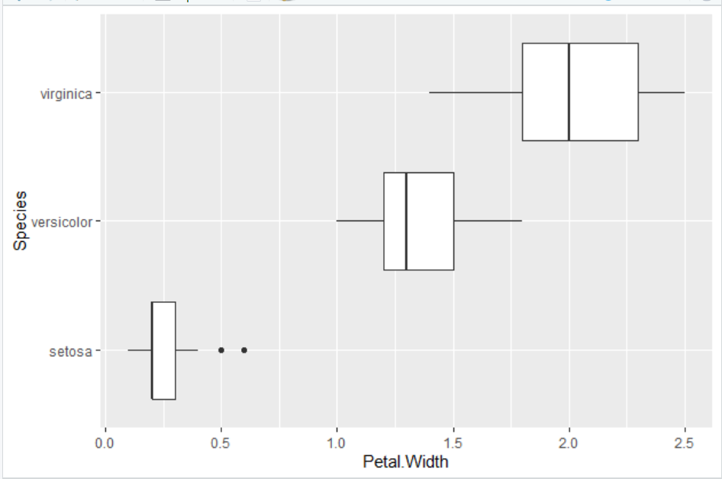

Marks 🡺 Area, lines, and points

Channels 🡺 Length and Area

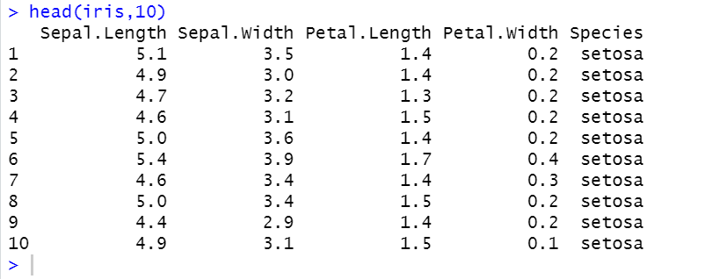

**Variables:** Sepal Length, Sepal Width, Petal Width and Petal Length

**Type:** Continuous, quantitative

**Variable**: Species

**Type**: Qualitative, nominal

## 2: FBI Crime dataset (box plots and time series)

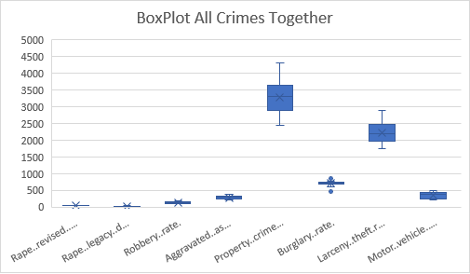

Marks 🡺 Area, lines, and points

Channels 🡺 Length and Area

Marks 🡺 lines

Channels 🡺 color



**Variables:** All the variables having Number of crimes (Murders, Violent crimes, property crimes etc) and Population

**Type:** Discrete quantitative ratio.

**Variables:** All the Rates

**Type:** Continuous, Quantitative, ratio

**Variables:** Year

**Type:** Ordinal categorical data

## 3: FBI Crime dataset (population plot)

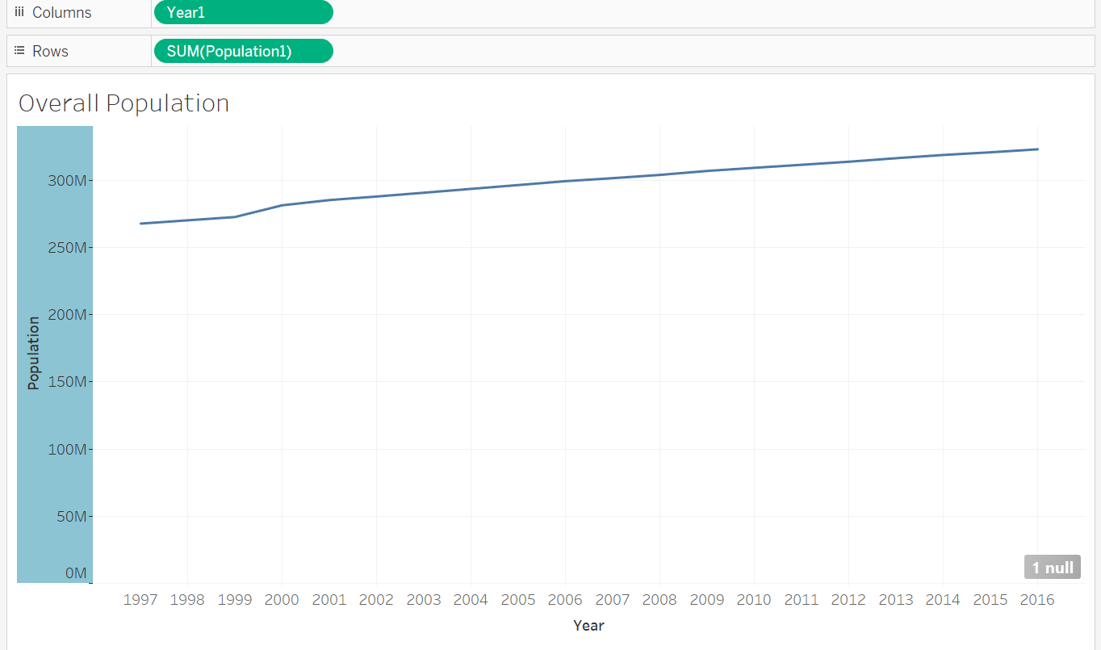

Marks 🡺 lines

Channels 🡺 color (no colors needed in this case)

## 4: Cancer dataset (boxplots, time plots, treemap)

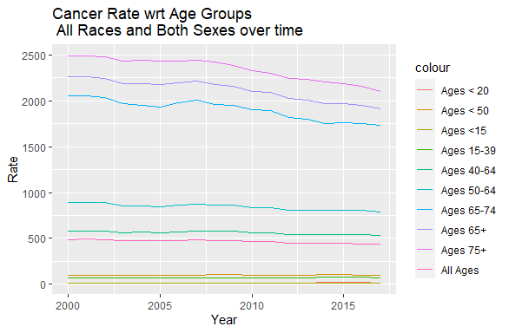

Marks 🡺 lines

Channels 🡺 color

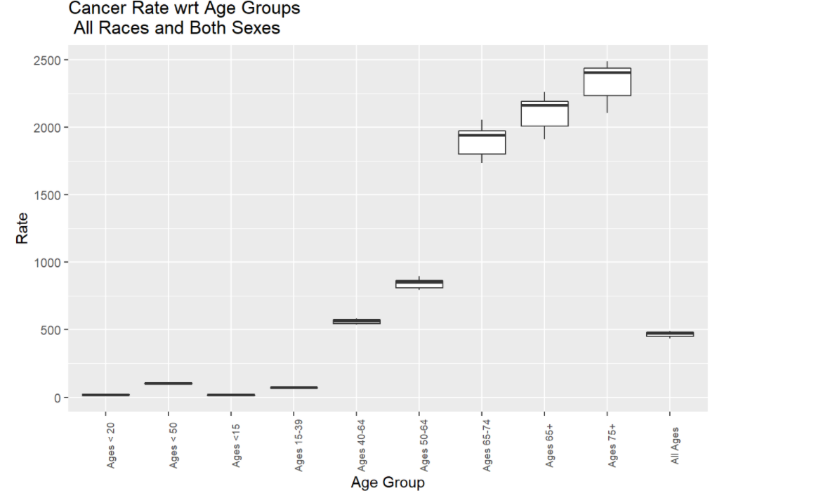

Marks 🡺 Area, lines

Channels 🡺 Length and Area

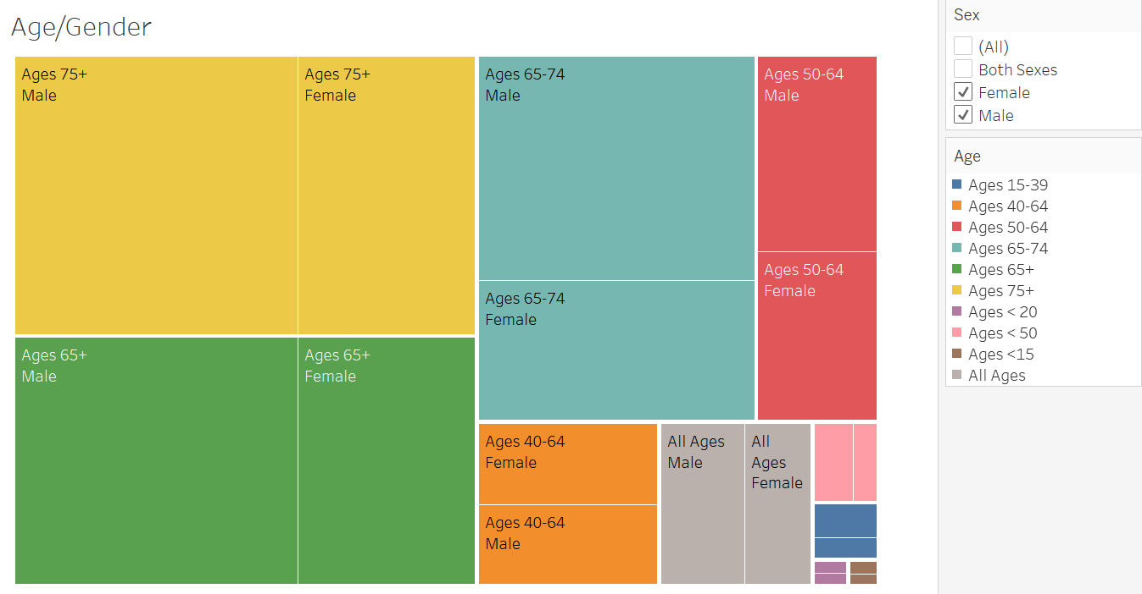

Marks 🡺 Area

Channels 🡺 color and Area



Sex 🡺 Categorical, Nominal

Age 🡺 Categorical Ordinal

Stage 🡺Categorical Ordinal ( in this case we have only all stages hence we could say nominal)

Rate Type 🡺 categorical nominal

Year 🡺 categorical, ordinal

Rate 🡺 Discrete Quantitative ratio

## 5: Temperature dataset (heatmap)

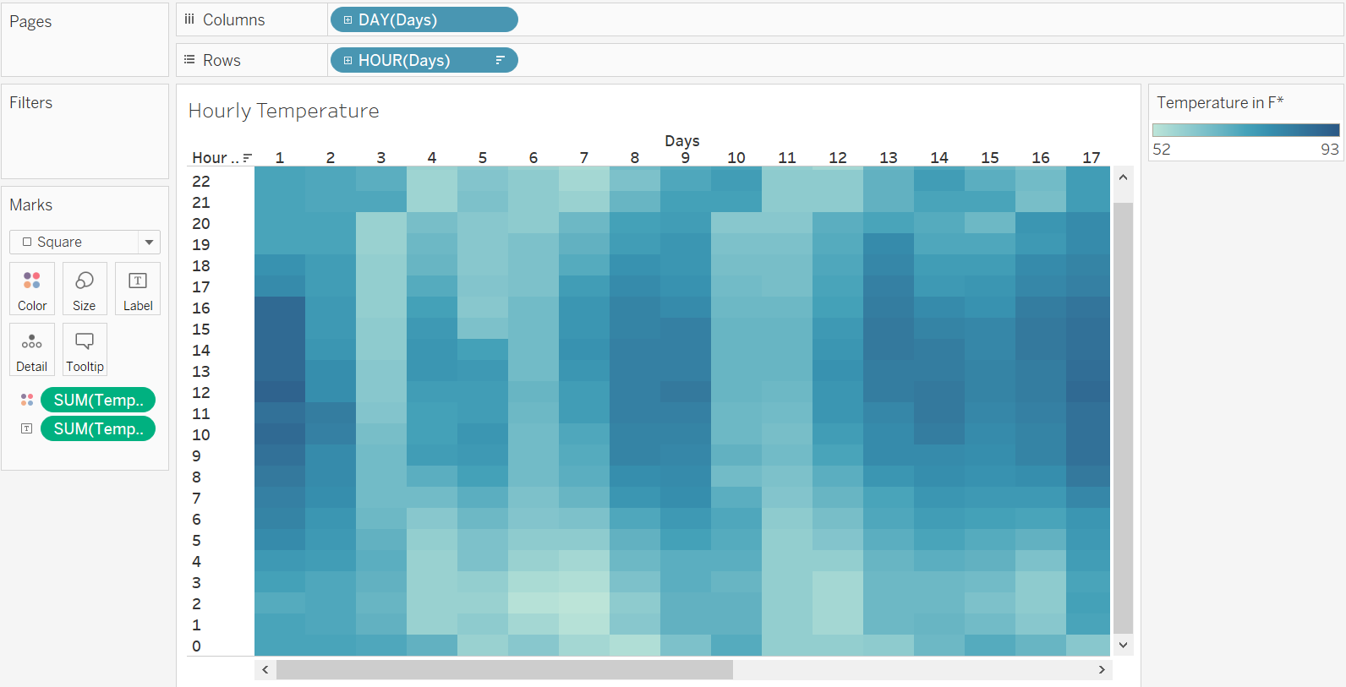

Marks 🡺 Area

Channels 🡺 Color



Sample Time 🡺 Categorical ordinal

Temperature 🡺 In actual temp is continuous quantitative Interval, however in this table it is discrete.

Humidity and Wind speed 🡺 In actual they are continuous quantitative but here they are discrete quantitative ratio.

## 6: Sales data (stacked bar chart)

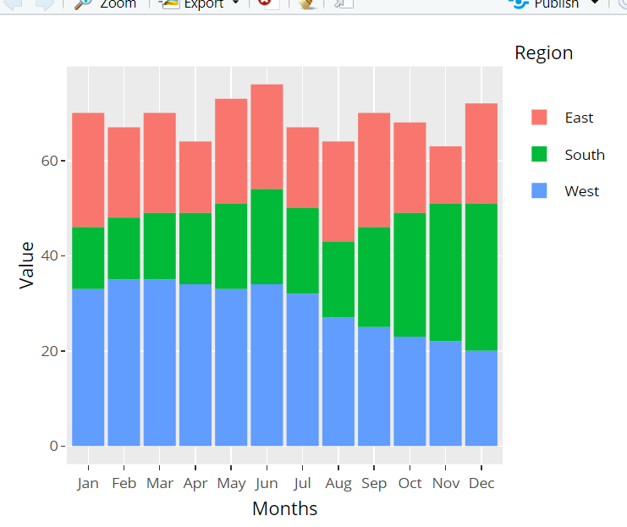

Marks 🡺 Area

Channels 🡺 Area, color



Region 🡺 Categorial nominal

All the Moths 🡺 Discreate quantitative

--- End ---